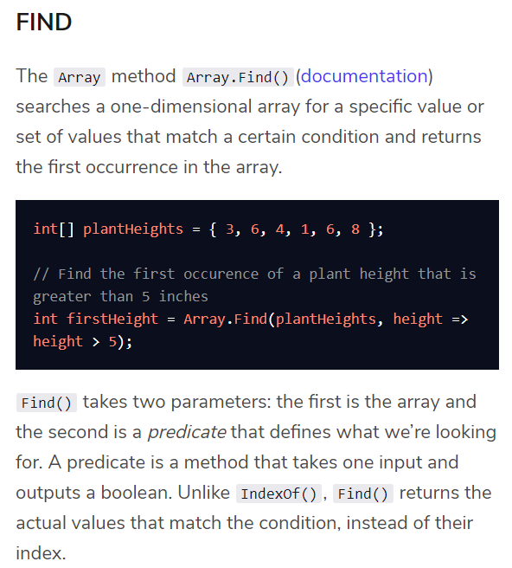

It’s customary to use a lambda function for the predicate to determine if the value meets the necessary criteria. If you need a refresher on lambda functions, check out our C# methods lesson.

* while loops are good when you know your stopping condition, but not when you know how many times you want a program to loop or if you have a specific collection to loop through.
* do...while loops are only necessary if you definitely want something to run once, but then stop if a condition is met.
* for loops are best if you want something to run a specific number of times, rather than given a certain condition.
* foreach loops are the best way to loop over an array, or any other collection.

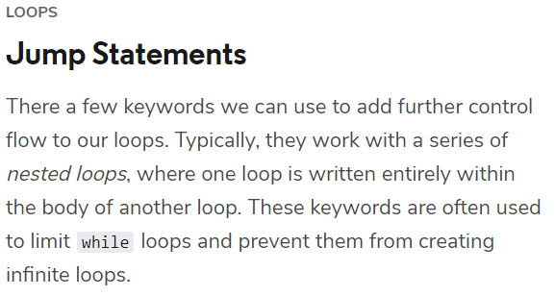

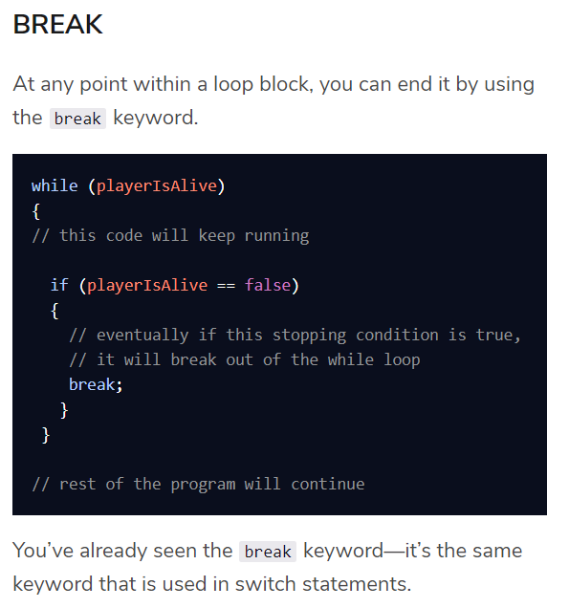

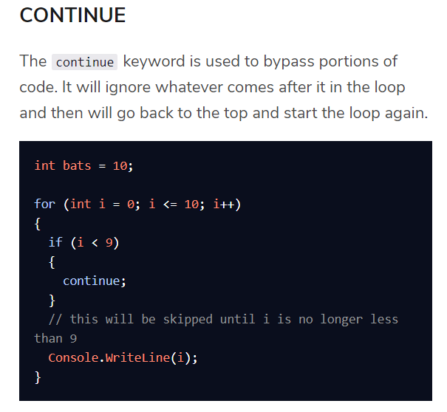

Here, the program starts in the for loop, then hits the if statement. Since there is a continue in the if statement, it will bypass the Console.WriteLine() statement until the condition in the if statement is no longer true. So while the loop starts at 0, nothing will print to the console until i is equal to 9.

**RETURN**

The return keyword is another way to exit a loop, specifically loops that are used within a method. When a return is used within such a loop, it breaks out of the loop and returns control to the point in the program where the method was called.

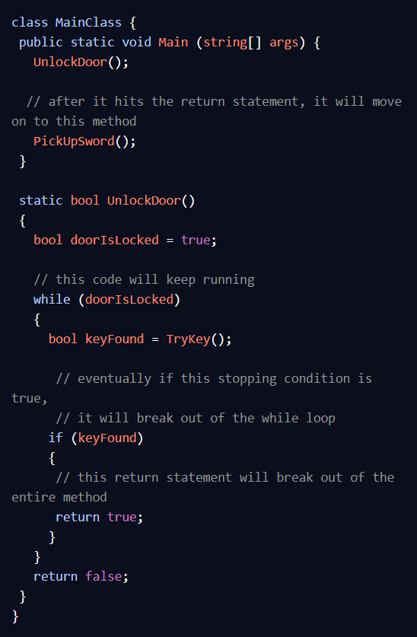

You should only use return if you need to exit a method, because it will break out of **all** loops. If you only want to break out of one loop and not exit a method, use break.

